**-FUN WITH FIDGET MATS-**

**FREE WORKSHOP**

**SATURDAY, MAY 31, 2025**

**10 AM – 2 PM**

EAST GREENWICH UNITED METHODIST CHURCH

1558 S. COUNTY TRAIL, E. GREENWICH, RI

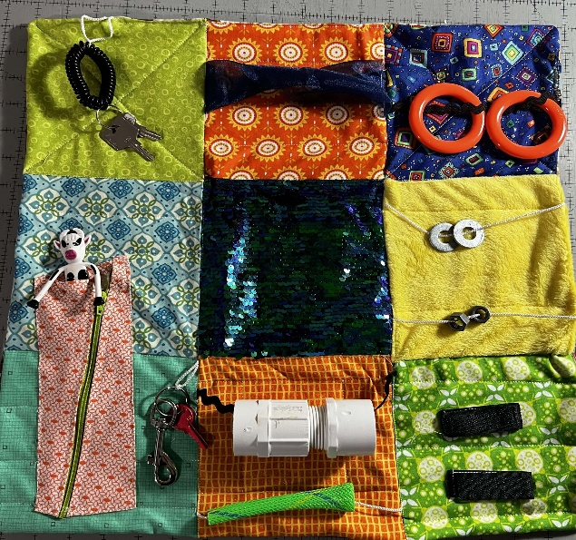

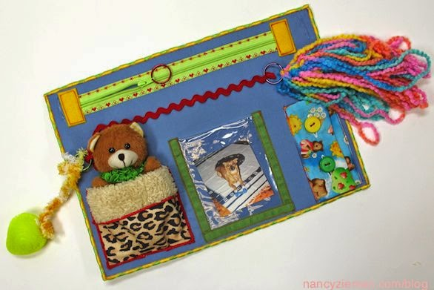

**SIGN UP FOR A FREE WORKSHOP WITH**

**GERI BERGREEN**

**ON LEARNING TO MAKE FIDGET MATS FOR**

**Dementia / Alzheimer’s Patients**

What You Will Need to Bring to Event:

-Sewing Machine – Notions - Different Types of Textured Fabrics-

-Any Kind of Fidget Items You May Have ( See Above for Examples) -

**-And Your Creativity-**

**THERE WILL BE A STASH OF MISCELLANEOUS TYPES OF FABRICS, AND FIDGET ITEMS, LACE, ZIPPERS, ETC, TO CHOOSE FROM AT EVENT** **TO HELP WITH YOUR FIDGET MAT CREATIONS.**